Business Analytics

NBA Draft Combine Measurements

Date: 28/07/2022

Garvit Malviya

**Document Version Control**

|  |  |  |  |
| --- | --- | --- | --- |
| **Date Issued** | **Version** | **Description** | **Author** |
| **1st July 2022** | 1.0 | NBA Draft Combine Measurements | Garvit Malviya |
|  |  |  |  |
|  |  |  |  |
|  |  |  |  |
|  |  |  |  |
|  |  |  |  |
|  |  |  |  |

# Contents

Document Version Control................................................................................2

Abstract.............................................................................................................3

1. Introduction............................................................................................. 5

* 1. Why this High-Level Design Document? ................................................5
  2. Scope......................................................................................................5

1. General Description................................................................................6

2.1Product Perspective & Problem Statement..............................................6

2.2Tools used ...............................................................................................6

1. Design Details ....................................................................................... 7
   1. Functional Architecture .................................................................................. 7
   2. Optimization ...................................................................................................... 8
2. KPIs................................................................................................................... 9
   1. KPIs (Key Performance Indicators) ...................................................................... 9
3. Deployment............................................................................................................ 9

# Abstract

The NBA draft is an annual event dating back to [1947](https://en.wikipedia.org/wiki/1947_BAA_draft) in which the teams from the [National Basketball Association](https://en.wikipedia.org/wiki/National_Basketball_Association) (NBA) can [draft](https://en.wikipedia.org/wiki/Draft_(sports)) players who are [eligible](https://en.wikipedia.org/wiki/Eligibility_for_the_NBA_draft) and wish to join the league. These are typically [college basketball](https://en.wikipedia.org/wiki/College_basketball) players, but international players are also eligible to be drafted. College players who have finished their four-year college eligibility are automatically eligible for selection, while the [underclassmen](https://en.wiktionary.org/wiki/underclassman) have to declare their eligibility and give up their remaining college eligibility. International players who are at least 22 years old are automatically eligible for selection, while the players younger than 22 have to declare their eligibility. Players who are not automatically eligible but have declared their eligibility are often called "early-entrants" or "early-entry candidates".

The draft usually takes place near the end of June, during the NBA offseason. Since 1989, the draft has consisted of two rounds; this is much shorter than the entry drafts of the other [major professional sports leagues in the United States and Canada](https://en.wikipedia.org/wiki/Major_professional_sports_leagues_in_the_United_States_and_Canada), all of which run at least seven rounds. Sixty players are selected in each draft. No player may sign with the NBA until he has been eligible for at least one draft.

.

# Introduction

## Why this High-Level Design Document?

The purpose of this High-Level Design (HLD) Document is to add the necessary detail to the current project description to represent a suitable model for coding. This document is also intended to help detect contradictions prior to coding, and can be used as a reference manual for how the modules interact at a high level.

The HLD will:

* Present all of the design aspects and define them in detail
* Describe the user interface being implemented
* Describe the hardware and software interfaces
* Describe the performance requirements
* Include design features and the architecture of the project
* List and describe the non-functional attributes like:
* Security
* Reliability
* Portability
* Maintainability
* Reusability
* Application Capability
* Resource Utilization
* Serviceability

## Scope

The HLD documentation presents the structure of the system, such as the database architecture, application architecture (layers), application flow (Navigation), and technology architecture. The HLD uses non-technical to mildly-technical terms which should be understandable to the administrators of the system.

# General Description

## Product Perspective & Problem Statement

Housing prices are an important reflection of the economy, and housing price ranges are of great interest for both buyers and sellers. In this project, house prices will be predicted given explanatory variables that cover many aspects of residential houses.

The objective of the project is to perform data visualization techniques to understand the insight of the data. This project aims apply various Business Intelligence tools such as Tableau or Power BI to get a visual understanding of the data.

## Tools used

Business Intelligence tools and libraries works such as Numpy, Pandas, Excel, R,

.



Tableau, Power BI are used to build the whole framework.

# Design Details

## Functional Architecture

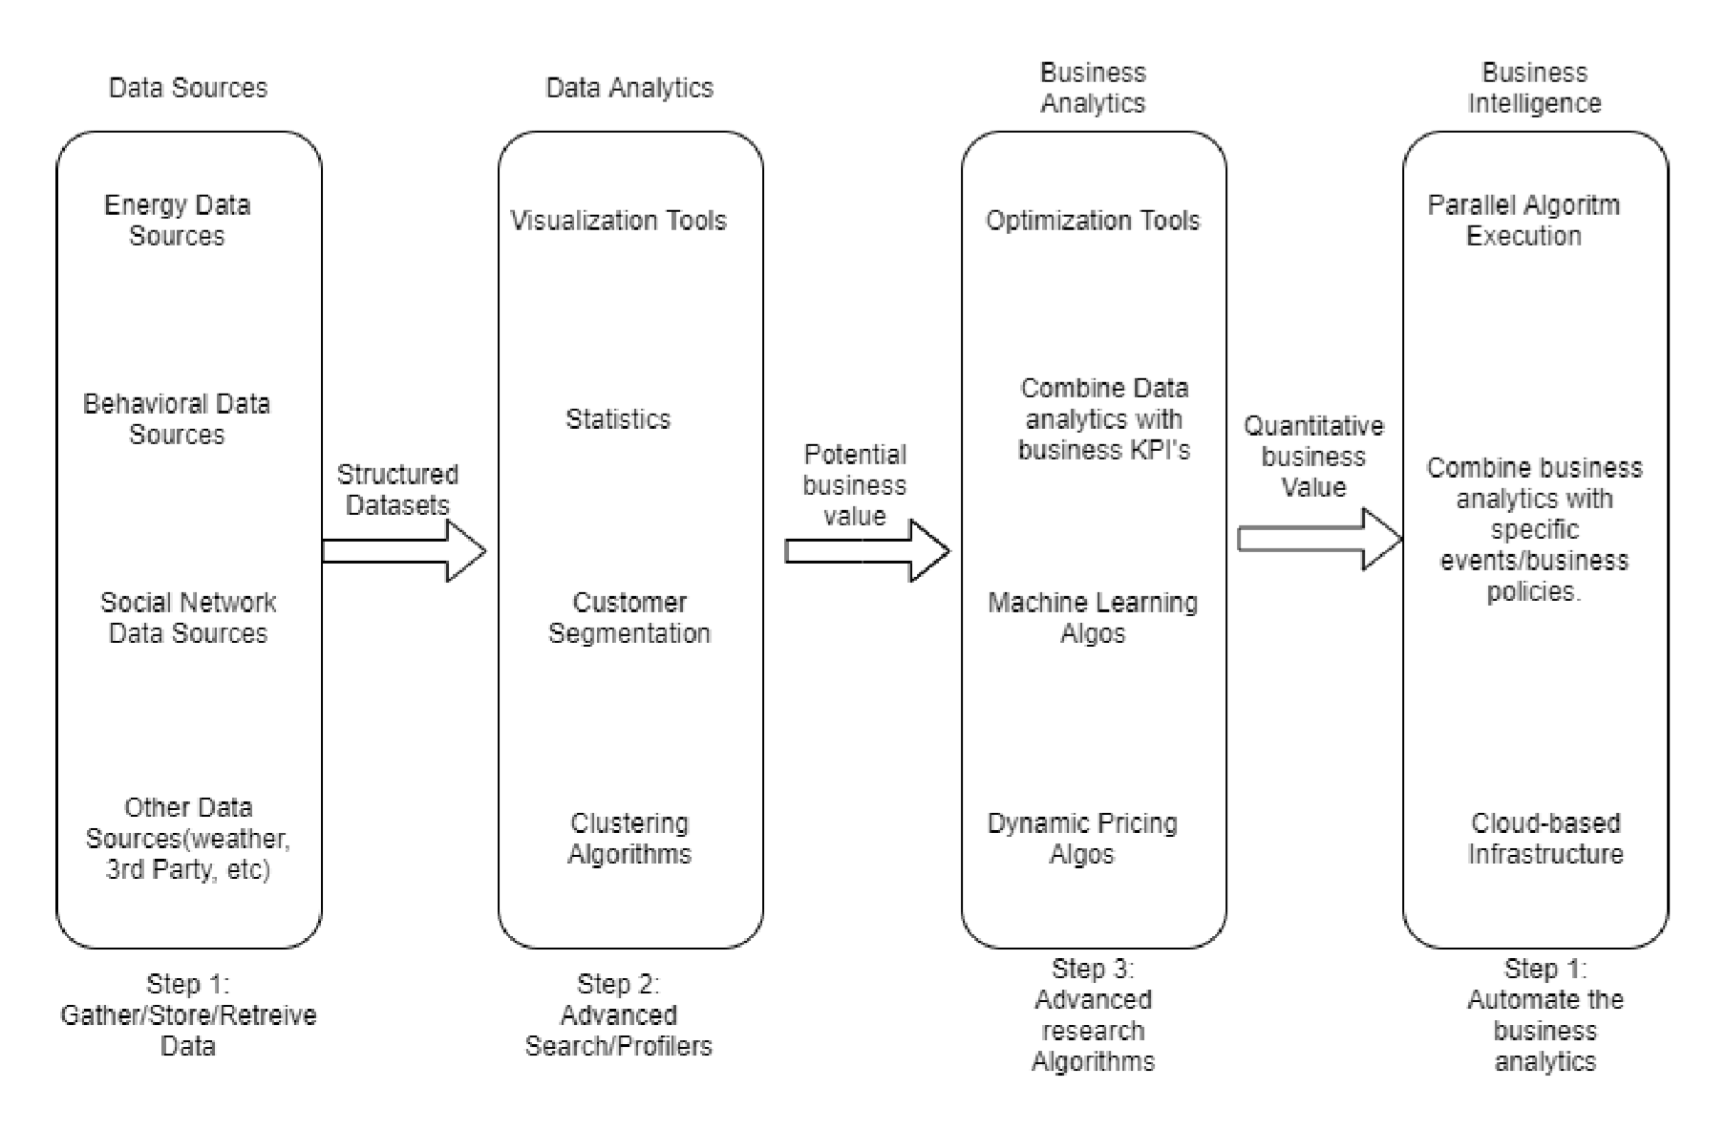

Figure 1: Functional Architecture of Business Intelligence 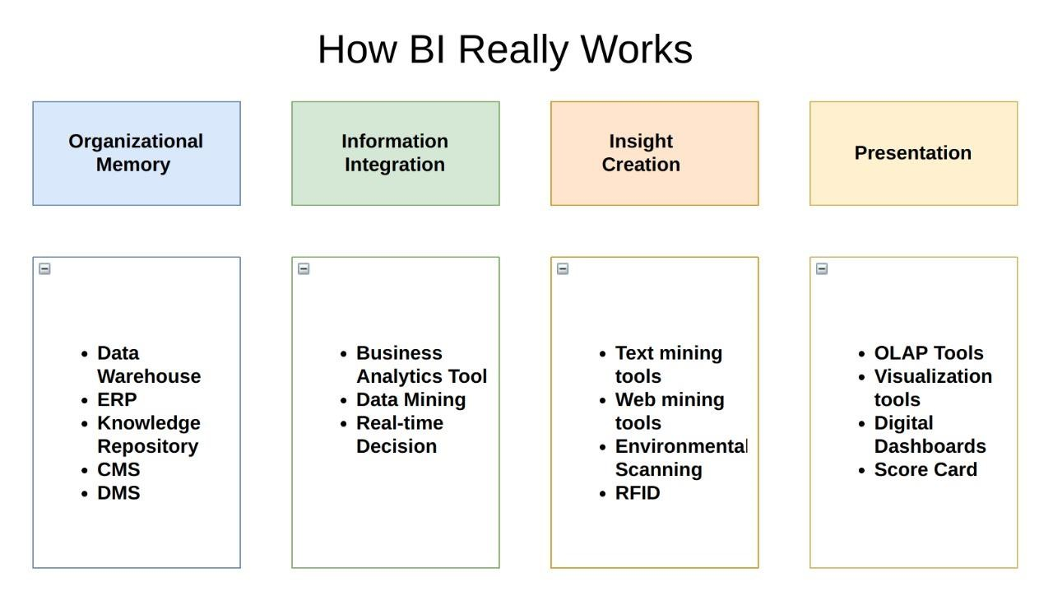

## Optimization

### Your data strategy drives performance

* Minimize the number of fields
* Minimize the number of records
* Optimize extracts to speed up future queries by materializing calculations, removing columns and the use of accelerated views

### Reduce the marks (data points) in your view

* Practice guided analytics. There’s no need to fit everything you plan to show in a single view. Compile related views and connect them with action filters to travel from overview to highly-granular views at the speed of thought.
* Remove unneeded dimensions from the detail shelf.
* Explore. Try displaying your data in different types of views. Limit your filters by number and type
* Reduce the number of filters in use. Excessive filters on a view will create a more complex query, which takes longer to return results. Double-check your filters and remove any that aren’t necessary.
* Use an include filter. Exclude filters load the entire domain of a dimension, while include filters do not. An include filter runs much faster than an exclude filter, especially for dimensions with many members.
* [Use a continuous date filter](http://onlinehelp.tableau.com/current/pro/online/mac/en-us/help.htm#filtering_add_dragfields_dates.html): Continuous date filters (relative and range-of-date filters) can take advantage of the indexing properties in your database and are faster than discrete date filters.
* [Use Boolean or numeric filters.](http://www.tableau.com/learn/tutorials/on-demand/logical-calculations) Computers process integers and Booleans (t/f) much faster than strings.
* Use [parameters](http://onlinehelp.tableau.com/current/pro/online/en-us/help.htm#parameters.html) and [action filters.](http://onlinehelp.tableau.com/current/pro/online/en-us/help.htm#actions.html) These reduce the query load (and work across data sources).

### Optimize and materialize your calculations

* Perform calculations in the database
* Reduce the number of nested calculations.
* Reduce the granularity of LOD or table calculations in the view. The more granular the calculation, the longer it takes.

LODs - Look at the number of unique dimension members in the calculation.

Table Calculations - the more marks in the view, the longer it will take to calculate.

* [Where possible, use MIN or MAX instead of AVG.](http://onlinehelp.tableau.com/current/pro/online/windows/en-us/help.htm#calculations_aggregation.html) AVG requires more processing than MIN or MAX. Often rows will be duplicated and display the same result with MIN, MAX, or AVG.
* [Make groups with calculations.](http://kb.tableau.com/articles/knowledgebase/creating-groups-using-calculated-fields) Like include filters, calculated groups load only named members of the domain, whereas Tableau’s group function loads the entire domain.
* [Use Booleans or numeric calculations instead of string calculations.](http://onlinehelp.tableau.com/current/pro/online/mac/en-us/help.htm" \l "functions_functions_string.html) Computers can process integers and Booleans (t/f) much faster than strings. Boolean>Int>Float>Date>Date Time>String

# KPIs

Dashboards will be implemented to display and indicate certain KPIs and relevant indicators

Dashboards will be included to display charts over time with progress on various indicators or factors

## KPIs (Key Performance Indicators)

Key indicators displaying a summary of the NBA Draft Measurement and its relationship with different metrics

1. Details of all the Player.
2. Year Slicer.
3. Average of height (with shoes) and height (without shoes) by year.
4. Count of hand (length) and count of hand (width) by year.
5. Count of vertical (No step reach) and count of vertical (No step) by year.
6. Count weight by year.
7. Height (with shoes) and weight by player.
8. Count of player.
9. Average of body fat by year.

# Deployment

In today’s world, analytics is a vital part of decision making in almost every organization. The growing use of Power BI as an analytics tool, requires it to use more data, look appealing and be user-friendly. Above all however, Power BI needs to always be available and reliable. To meet these requirements, BI creators must collaborate effectively.

The deployment pipelines tool enables BI creators to manage the lifecycle of organizational content. It's an efficient and reusable tool for creators in an enterprise with Premium capacity. Deployment pipelines enable creators to develop and test Power BI content in the Power BI service, before the content is consumed by users. The content types include reports, paginated reports, dashboards, datasets and dataflow.

The tool is designed as a pipeline with three stages:

1. Development:

This stage is used to design, build, and upload new content with fellow creators. This is the first stage in deployment pipelines.

1. Test

You're ready to enter the test stage after you've made all the needed changes to your content. You upload the modified content so it can be moved to this test stage. Here are three examples of what can be done in the test environment:

* Share content with testers and reviewers
* Load and run tests with larger volumes of data
* Test your app to see how it will look for your end users

1. Production

After testing the content, use the production stage to share the final version of your content with business users across the organization.